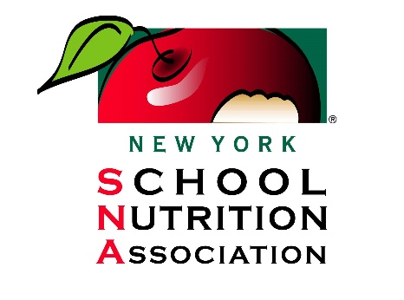

FOR IMMEDIATE RELEASE
June 8, 2022

Contact: Ashleigh Roche Jo Ann LeSage Nelson
ashleigh@nyschoolnutrition.org joann@albanypr.com
(518) 446-9061 (518) 928- 4134

New York School Nutrition Association hosts food drive
to benefit Karyl’s Kupboard

Albany, N.Y. – The New York School Nutrition Association (NYSNA) will host a food and hygiene drive on Friday, June 10, to benefit Karyl’s Kupboard, a food pantry run by CAPTAIN Community Human Services. The goal is to raise 10,000 in a combination of monetary donations and pounds of food collected.

From noon to 2 p.m. on June 10, participants can help NYSNA reach its goal by stopping by the NYSNA headquarters at 21 Executive Park Dr. in Halfmoon and dropping off donations as well as grab a hot dog, play some games and visit with the NYSNA and CAPTAIN teams.

Items that are needed most include canned fruits and vegetables, canned soups, ramen, baking goods, seasonings, condiments, jelly, individual juice boxes, individual snacks (for kids), shampoo and conditioner, soap, body wash, laundry soap, disinfectant wipes, dish soap and other cleaning supplies. Online monetary contributions may also be made up until, June 10 by visiting, www.captaincares.org/nysna.

Karly’s Kupboard is an emergency food and hygiene pantry located in Clifton Park and is open to any resident of Saratoga County who is in need of the supplies it provides. With the Healthy School Meals for All act no longer being funded, 800,000 New York students will lose access to free meals. This means that places like Karyl’s Kupboard may start to see an uptick in the number of people who turn to it for assistance in getting food for their children. The donations raised through NYSNA will help Karyl’s Kupboard be prepared for this possibility.

# # #
About the New York School Nutrition Association:
The New York School Nutrition Association is a cohesive group of school nutrition employees, managers, directors, registered dietitians, nutritionists, and industry members in New York State committed to ensuring that all students have access to healthy meals. NYSNA provides information, services, and continuing education to school nutrition and food service professionals in New York State. For more information: https://www.nyschoolnutrition.org/

