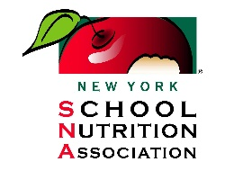
Farm to School Partnership Awards Application
Due on or before December 31st each year
E-mail Completed Submissions To: jennifer@nyschoolnutrition.org

District or School Name: ____________________________________________________________________
Person Submitting Application: ______________________________________________________________
Phone: _____________________________________ Email: _______________________________________

The Farm to School Partnership Award was created in partnership between the New York School Nutrition Association and New York State Department of Agriculture & Markets. This award highlights exemplary farm to school projects across New York State. Applications are reviewed by the New York School Nutrition Association and New York State Department of Agriculture & Markets. Up to four awards will be selected each year to receive this prestigious award at the New York School Nutrition Association Legislative Action Conference. One complimentary dinner meal and plaque will be given per winning application.
Ideas for projects include: merchandising/promoting local foods, working with local farms, building partnerships and integrating farm to school into wellness activities, and distribution: finding creative ways to get or receive local farm products.
Written application not to exceed 3 pages Times New Roman 12- Point Font. Project summary and response to each question is required. Attach photos or video to the e-mail or in a separate word document.

Content To Be Included:
Project Summary: Please provide a summary of your farm to school project.
Question #1: Transferability: How is the project able to be replicated in other districts or areas?
Question #2: Impact/Measurability: who and how did the submission impact the children, schools, farms and/or communities?
Question #3: Innovation: How does the project show improved and creative ways to use local farm products?
Question #4: Sustainability: Explain how activity is something that can be completed every year or demonstrate growth from one year to the next.

